KINDERGARTEN CLASS REQUIREMENTS – 2025

These items will be stored and shared among the class throughout the year  (no names required )  - 2 x 10 pack of black whiteboard markers ($5 per pack from Kmart)  - 8 x glue sticks (UHU or Bostik brand recommended)  - 2 x tissue boxes  - 2 x large packets of wet wipes  - 2 x 12 packs of Twistable crayons (Crayola)  - 1 x 20 pack of Textas (Faber Castell) | For your individual child  Please ensure all items are clearly labelled with your child’s name  - 2 A4 plastic document wallets (diary to be kept  - Inside the wallet)  - 1 library bag  - On-Ear Wired Headphones - Black - Kmart  - 1 A3 Display book J.Burrows A3 20 Pocket Display Book Black | Officeworks  - 1 student diary  (see picture below-no larger than A5)  - Paint Shirt  - Spare underwear and socks (to be kept in bag)  - Lunch box and water bottle (easily opened by your child and labelled)

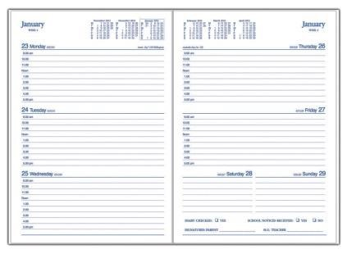

The kindergarten teachers look forward to welcoming you to our St Cecilia’s community in 2025.

